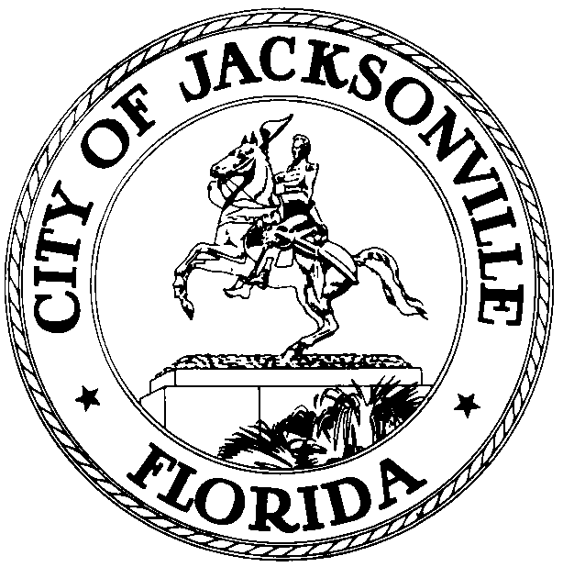

Office of the City Council
Legislative Services Division

Jessica B. Matthews 117. W. Duval Street
Chief of Legislative Services Suite 430
OFFICE (904) 255-5122 Jacksonville, Florida
FAX (904) 255-5132 32202

June 18, 2020
(5:00 p.m.)

Meeting Notice

Notice is hereby given that the Jacksonville Waterways Derelict Vessels and Floating Structures Committee members, Commissioner Lindsey Brock, Chair, and Commissioner Marshall Adkison, Ex-Officio, will meet to discuss local legislation to regulate floating structures and enforcement of derelict vessels. The meeting will convene on Monday June 22nd, 2020 from 9:00 AM – 10:30 AM in the Lynwood Roberts Room on the 1st Floor, City Hall, St. James Bldg., 117 West Duval Street, Jacksonville, FL 32202.

Please mark your calendars accordingly. All interested parties are invited to attend. Please contact Jessica Smith or Sharonda Davis at (904) 255-5122 for additional information or correspondence.

JBM/js

E-mail: Council Members/Staff
Cheryl Brown, Director/Council Secretary
Jeff Clements, Chief of Research
Susan Grandin, General Counsel
CITYC@COJ.NET
Posted Notice Board, 1st Fl, City Hall
Public Notice System, City Council Web Page
Media Box

